## Overview

In this activity, you will customize your site’s footer with a call to action (CTA).

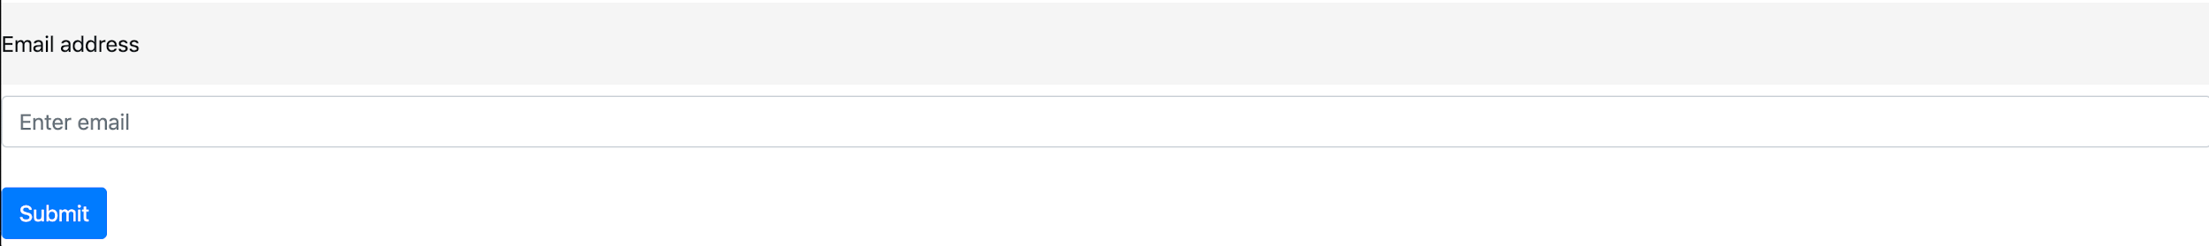

**⇩**



## Instructions

**Part 1: Update the HTML**

1. Add the emailContain class to the <footer> tag.
2. Next, add a <h3> tag within the <form> tag, but above the form-group <div>.
   * Type **Join Our Mailing List** within the <h3> tag.

**Part 2: Update the CSS**

1. Add the following selectors, properties, and values to spruce up the footer and the form contained within:

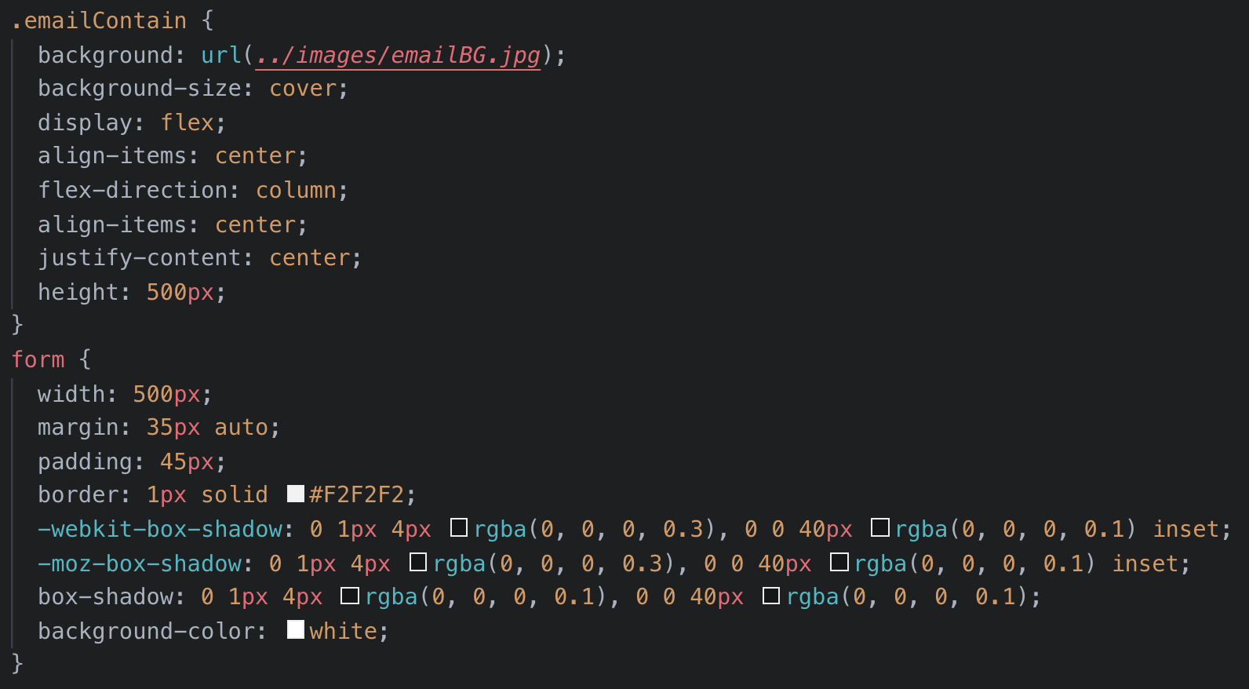

1. That’s it! Your design is complete! Refresh your browser to see all the changes you’ve made and how far your template has come.
2. You have completed your Bootstrap template.
3. That’s it for our template; you now have a fully responsive Bootstrap 4 template ready for you to customize and use professionally.

Feel free to modify it further if you’d like. You could create a different style or, alternatively, add more content to your Bootstrap template (this could be more sections, redoing of some sections, etc.).

Great work!